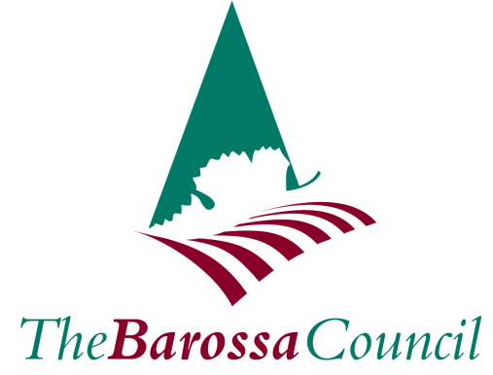

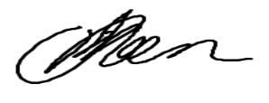
Jo Moen
Acting Chief Executive Officer
The Barossa Council

Recording of Council Meeting

Due to technical difficulties, the recording of the Ordinary Council meeting held on 15 August 2023 is not available.

